20. Load Exotics:

The exotic field will be the sum of all the fields that contain word parlay and its correspondent sport:

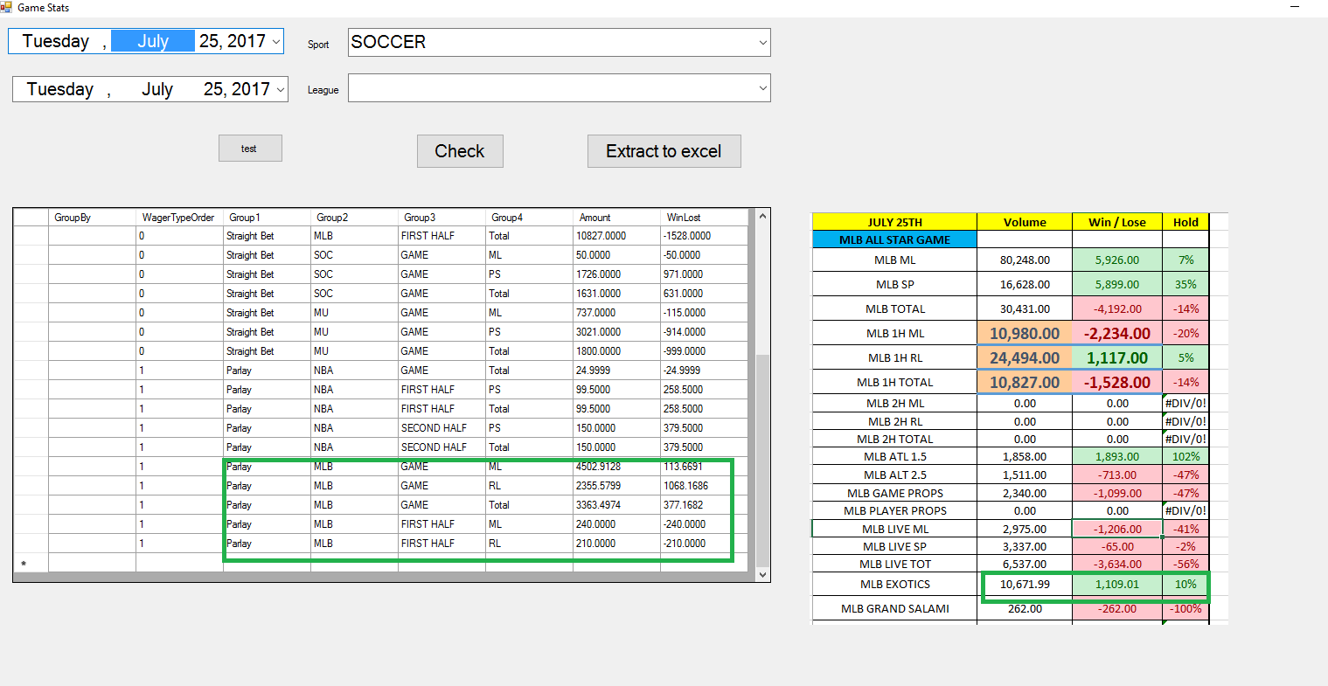

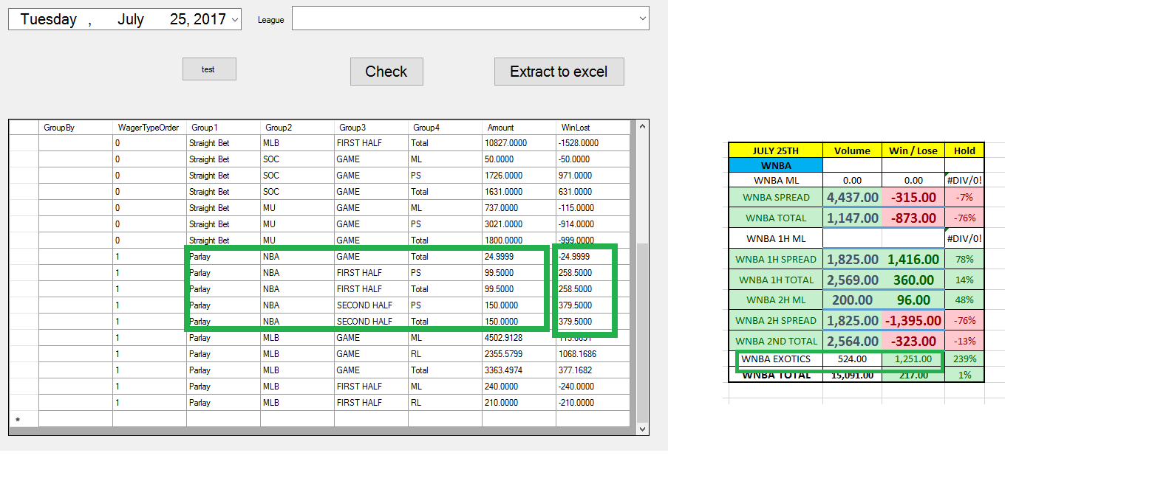

21: Load Soccer and WNBA Fields:

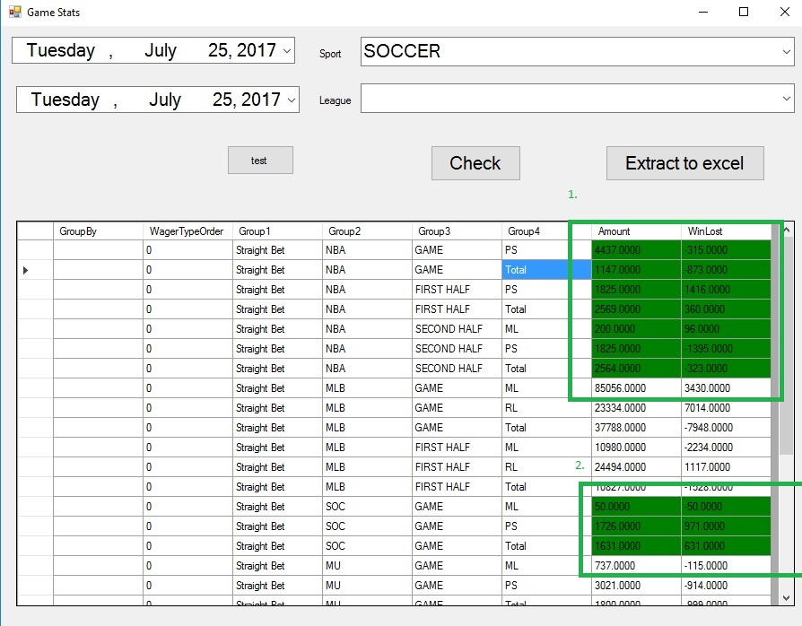

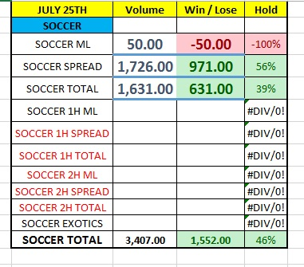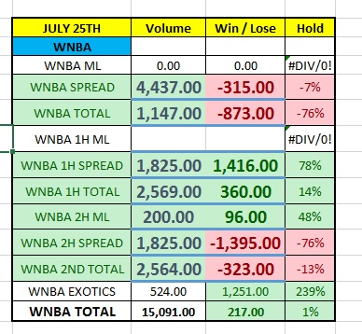

From last reports, will be loaded next fields:

Soccer ML Will be loaded from cell that contain SOC + GAME + ML

Soccer spread will be loaded from cell that contain SOC + GAME + PS

Soccer total will be loaded from cell that contain SOC + GAME + Total

WNBA spread will be loaded from cell that contain NBA + GAME + PS

WNBA total will be loaded from cell that contain NBA + GAME + Total

WNBA 1h Spread will be loaded from cell that contain NBA + First Half + PS

WNBA 1h Total will be loaded from cell that contain NBA + First Half + Total

WNBA 2H ML will be loaded from cell that contain NBA + Second Half + Total

WNBA 2h Spread will be loaded from cell that contain NBA + Second Half + PS

WNBA 2h Total will be loaded from cell that contain NBA + Second Half + Total

**EXOTICS:**

**WNBA EXOTICS: All Rows that contain parlays and NBA.**

**MLB Exotics: All rows that contain parlays and MLB.**

**MLB:**

**Attached excel with docs**

**After this, each one of the next needs to be loaded report by report.**

Japanese Baseball: Sum of all from ML BASEBALL – JAPANESSE BASEBALL

MLB SERIES: ML BASEBALL – MLB SERIES PRICES

Next 3: ML BASEBALL - MLB - LIVE WAGERING

|  |  |  |  |
| --- | --- | --- | --- |
| MLB GAME PROPS | 2,846.00 | -287.00 | -10% |

* from ML BASEBALL – JAPANESSE BASEBALL

|  |  |  |  |
| --- | --- | --- | --- |
| MLB ML | 101285 | -27409 | -0.2706126 |
| MLB SP | 20595 | -16859 | -0.8185967 |
| MLB TOTAL | 23696 | 2836 | 0.11968265 |

Loaded from ML BASEBALL - MAJOR LEAGUE BASEBALL

|  |  |  |  |
| --- | --- | --- | --- |
| MLB 1H ML | 7926 | -5483 | -0.6917739 |
| MLB 1H RL | 10950 | 6347 | 0.5796347 |
| MLB 1H TOTAL | 6079 | 3256 | 0.53561441 |

Loaded from MLB - 1ST HALVES (5 FULL INNINGS)

Pending: MLB 2H, NOT DATA ON LAST WEEKS, NEITHER ARENA FOOTBALL AND CANADIAN FOOTBALL.